Low-frequency spin qubit energy splitting noise in highly purified ²⁸Si/SiGe

A. Schmidbauer ⁽¹⁾, T. Struck ⁽²⁾, A. Hollmann ⁽²⁾, L. Diebel ⁽¹⁾, R. Richter ⁽¹⁾, M. Zoth ⁽¹⁾,
H. Riemann ⁽³⁾, N. Abrosimov ⁽³⁾, Ł. Cywiński ⁽⁴⁾, L. Schreiber ⁽²⁾, and Dominique Bougeard ⁽¹⁾
(1) Institut für Experimentelle und Angewandte Physik, Universität Regensburg, Regensburg, Germany
(2) JARAFIT Institute Quantum Information, Forschungszentrum Jülich GmbH and
RWTH Aachen University, Aachen, Germany
(3) Leibniz-Institut für Kristallzüchtung, Berlin, Germany
(4) Institute of Physics, Polish Academy of Sciences, Warsaw, Poland

Electrostatically defined quantum dots in ²⁸Si/SiGe heterostructures have been proven to allow the robust implementation of spin qubits as long as the device-intrinsic valley splitting energy is sufficiently large to operate the qubit. Here, we present the characterization of a gate-defined single spin qubit in a quantum dot layout with an integrated nanomagnet. The qubit is hosted in a molecular-beam epitaxy-grown ²⁸Si/SiGe heterostructure presenting 60 ppm residual ²⁹Si^{[1]}. We find a robust valley splitting beyond 200 𝜇eV and a well separated orbital energy beyond 1 meV. In the operation window, we observe spin relaxation times 𝑇₁ > 1 s. Using electron dipole spin resonance, the manipulation of the qubit yields 𝑇₂* ∼ 20 𝜇s and 𝑇₂^{𝑒𝑐ℎ𝑜} ∼ 127 𝜇s^{[2]}. We investigate the detuning noise spectrum of the qubit by extracting the resonance frequency from a series of Ramsey-type measurements and compare this noise to the noise spectrum of the adjacent sensor dot. We find charge noise together with the synthetic spin-orbit interaction due to the magnetic gradient to be the dominant qubit noise source at frequencies larger than 5 mHz. Given that the SiGe barrier has natural isotope composition, we also discuss the impact of the electron wavefunction overlap with the Si/SiGe interface on the qubit dephasing time.

[1] A. Hollmann et al., Phys. Rev. Applied 13, 034068 (2020)
[2] T. Struck et al., npj Quantum Inf. 6, 40 (2020)
[3] T. Struck et al., Sci. Rep. 11, 16203 (2021)

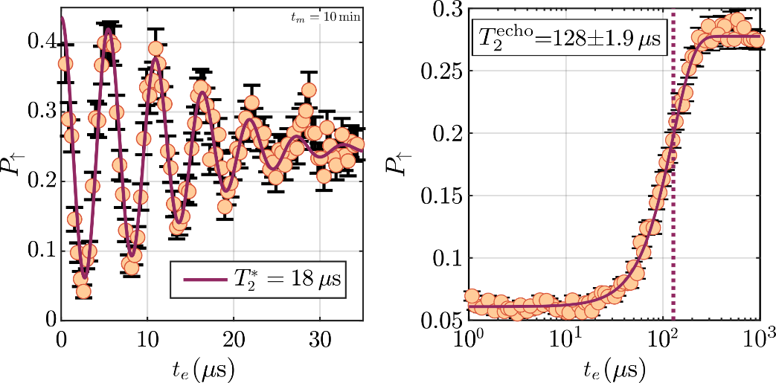
Figure 1: Left: Measurement of the spin-up probability as a function of the evolution time t_{e} for a Ramsey-fringes pulse sequence. Each point corresponds to 500 single-shot measurements^{[3]}. Right: Spin-up probability as a function of the evolution time t_{e} after a Hahn-echo gate sequence. The dotted line marks the fitted^{[2]} T₂^{echo}.

